The baylander
A monthly newsletter for the Baylander barbershop chorus
Volume 16, Issue 1 January 2016
Happy New Year
Welcome to another new year for the Baylander Barbershop Chorus. We ended last year with our traditional Christmas Concert and Tannenbaum Express. We even got our picture with Santa Clause who was visiting at the Mall. We now are looking forward to the exciting events scheduled for 2016. Here are some dates to put on your calendar. We wish to thank all the men who joined us during our Christmas season to sing with us on the Christmas Concert and Tannenbaum Express.
- Jan 22, 23 Barbershop Workshop at River Falls
- Jan 30, 2016 9am to 4pm Youth Harmony Workshop at Green Bay East High School.
- Feb 12, 13, 14 Singing Valentines in Green Bay and Shawano
- Apr 30 Spring Show “Ain’t A That Good News” Two shows 3pm and 7pm with Afterglow.
Start thinking about Singing Valentines
Valentines is only about a month away. I was in the store yesterday and already saw the Valentine Candy on the shelves.

Youth Harmony Workshop
Super Sing 2016
Bill and John have been working hard on our Youth Harmony Workshop. It will be held at Green Bay East High School from 9am to 4pm with a concert at 4pm. Last year we invited both boys and girls to attend. Check out our website at www.baylanders.org to view videos of last year’s performances.
2016 Board Members

The following are the 2016 Green Bay Chorus Board Members
Jim Harsh Media
Bob Wozniak Membership
Bob Cook Secretary
Bill Schmidt President
Jon Wolfe Treasurer
John Dessart Music and Performance Coordinator

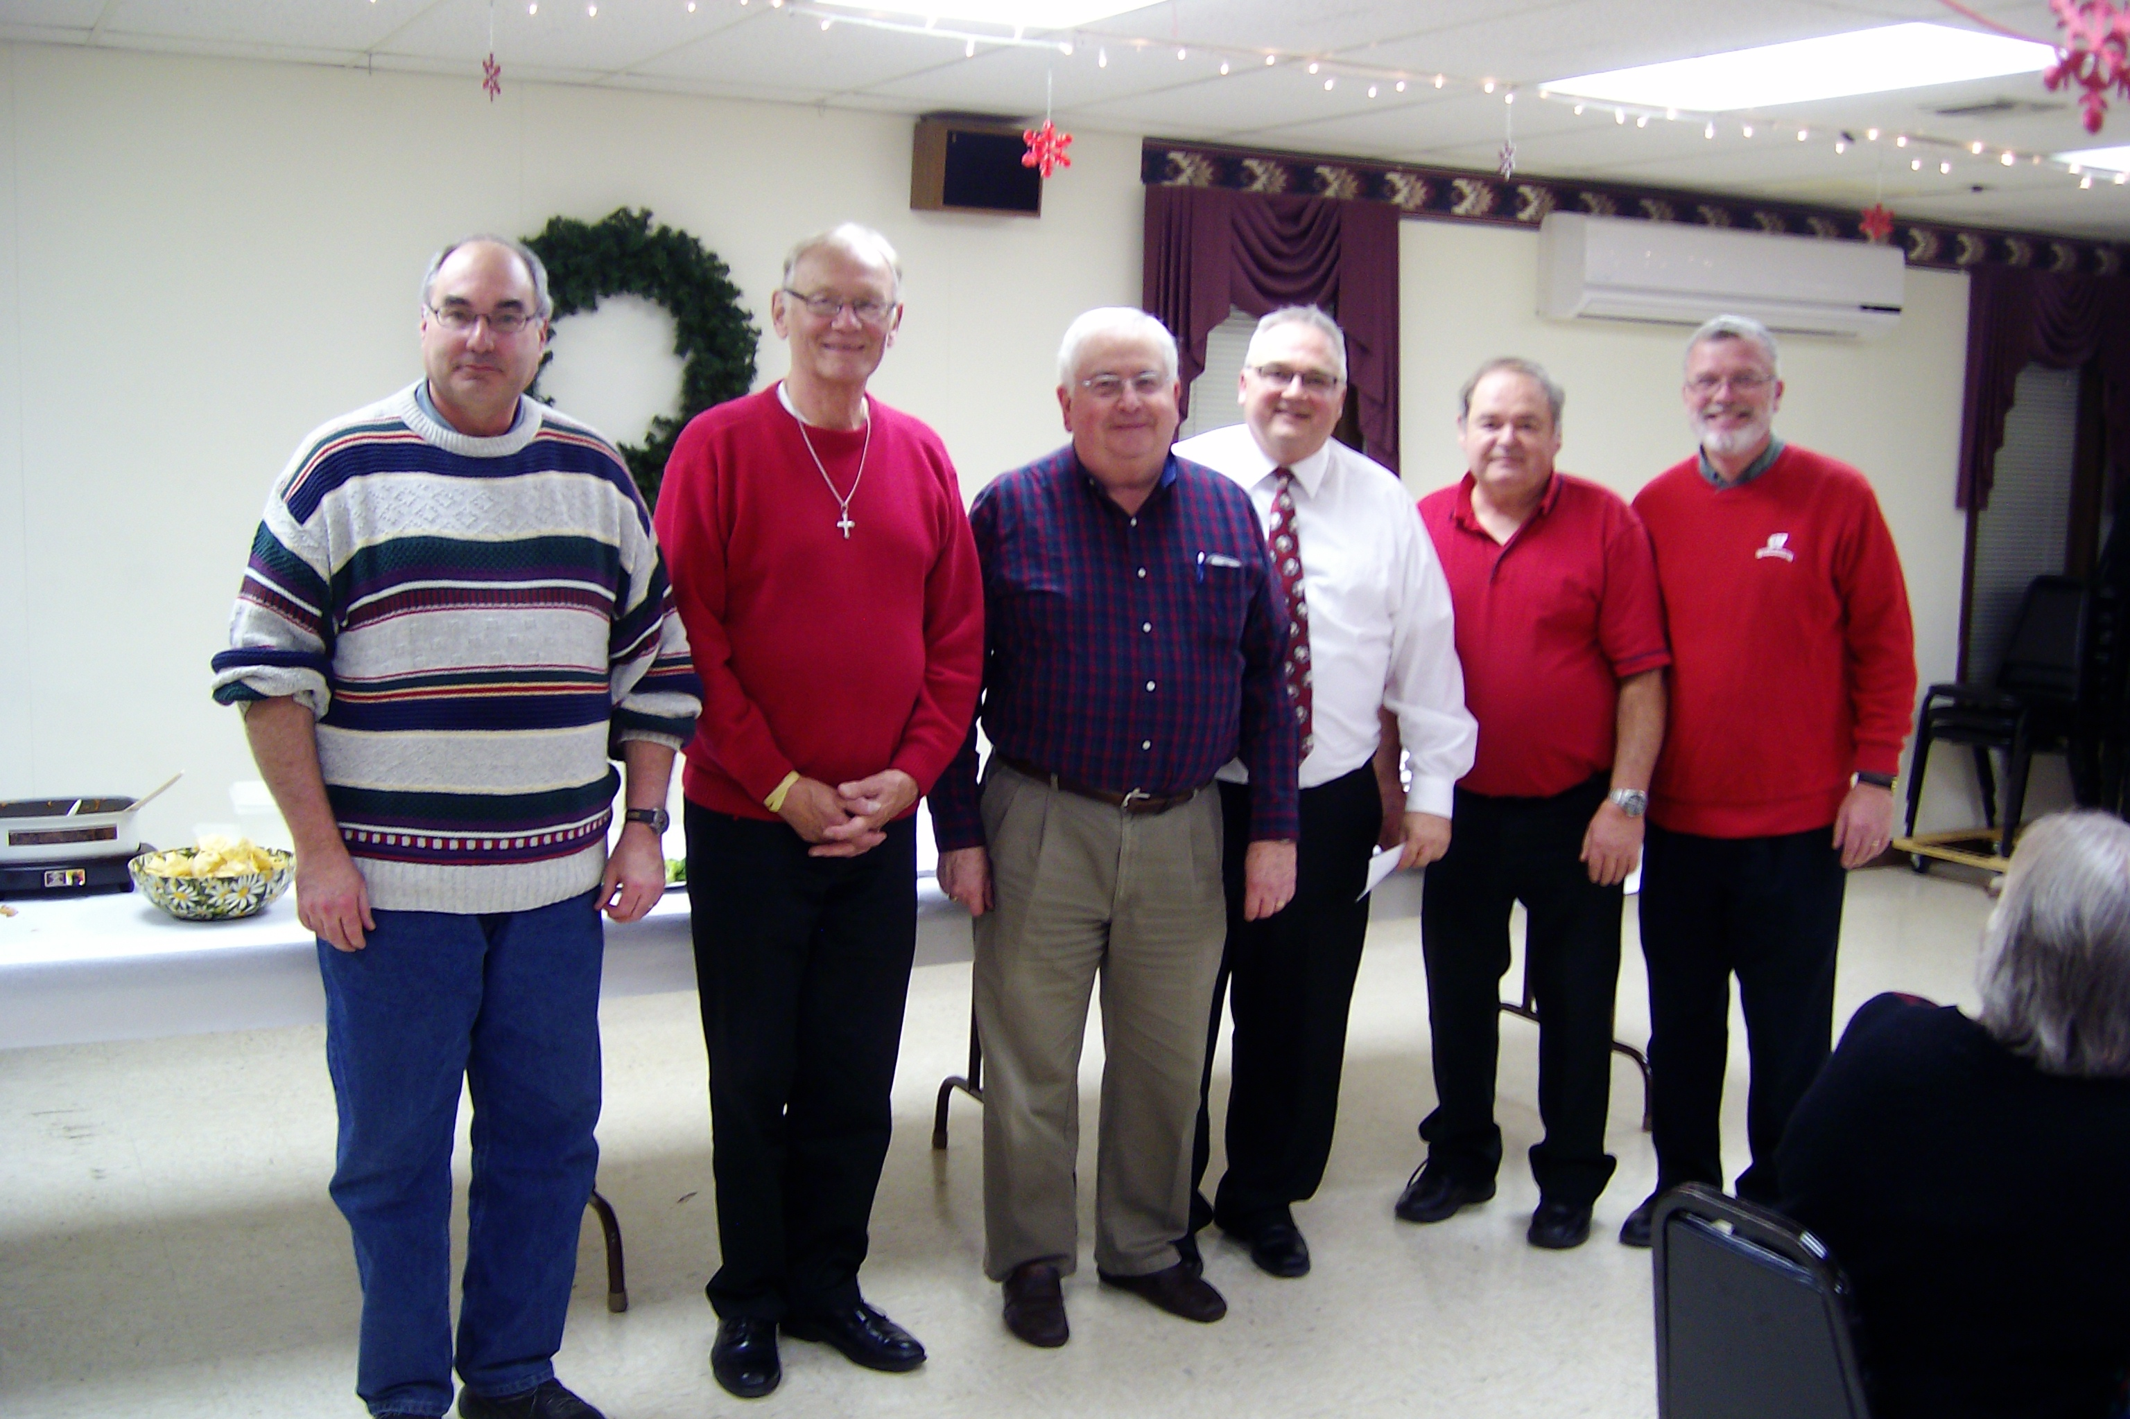

Inside This Issue

Youth Harmony Workshop
Valentines
Spring Show
Valentines
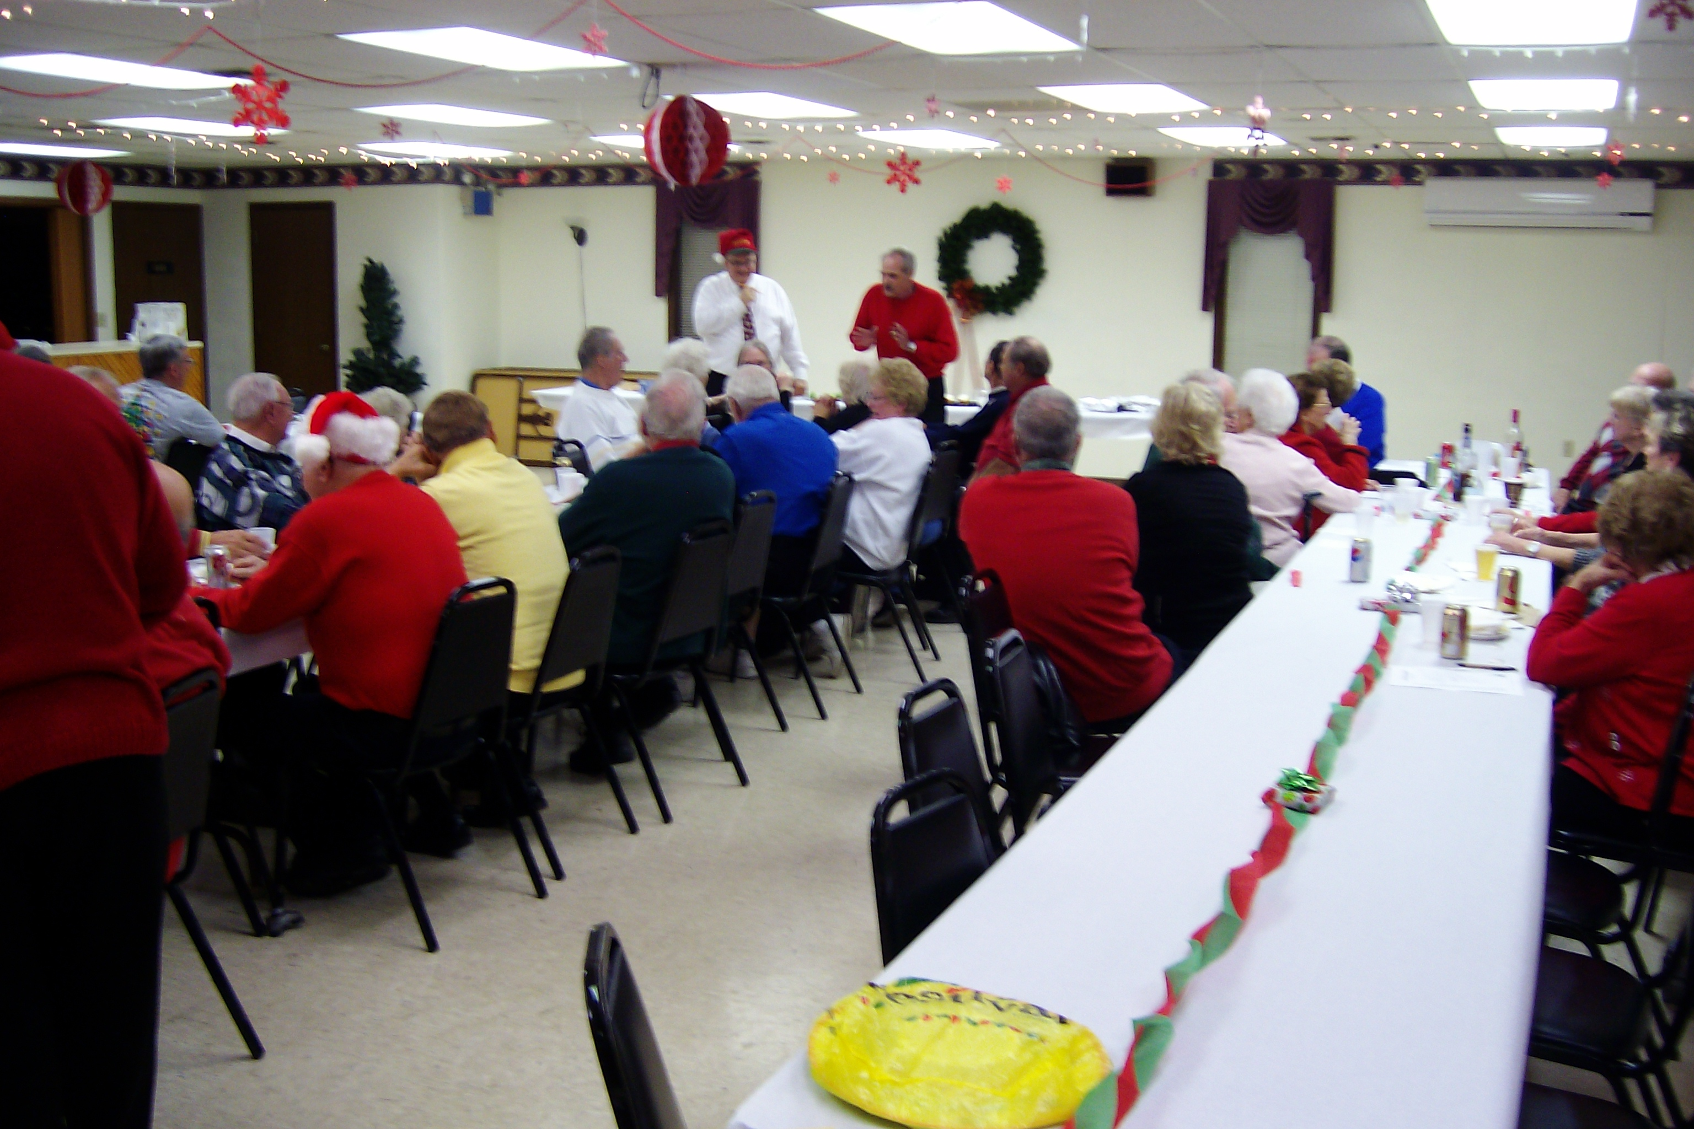
Christmas Party

Spring Show

Ain’t A That Good News

Our spring show will be on April 30th with shows at 3pm and 7pm. Our guest quartet will be “Shoptimus Prime” They are the International Collegiate Silver Medalists for 2013. Check out their website at www.shoptimusprimequartet.com

.

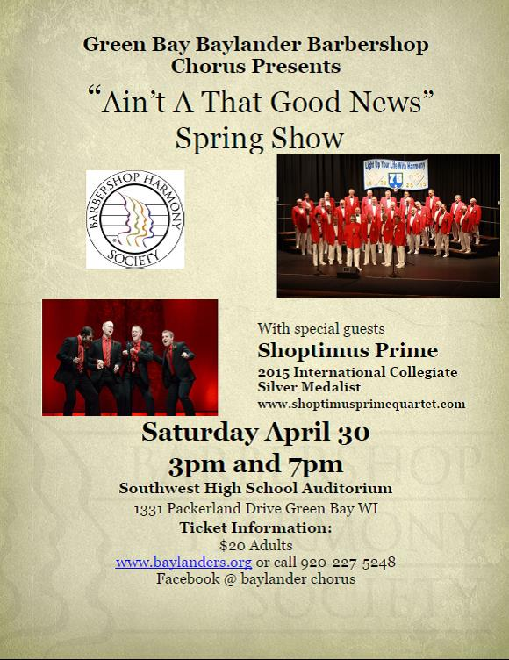
Rehearsal Schedule
Monday’s 7:15 to 9:30 Green Bay Elks Lodge

If you have any information you wish to add to the newsletter please send an e-mail to Jim Harsh at ronald.j.harsh@gmail.com.

Board Meeting
January 11 at 6:30pm

