The baylander
A monthly newsletter for the Baylander barbershop chorus
Volume 16, Issue 4 April 2016

Helpers Needed
We will need helpers to paint sets for the Spring Show contact Jim Emmel if interested in helping. We will also need people to load and haul the risers over to the church before our dress rehearsal.
Awards Banquet
The board will be discussing our awards banquet at the next board meeting. We have not set up a date or location for the banquet. If anyone has some ideas for a location that would meet our needs please contact any board member.

Show Progress
We are continuing to make good progress selling ads for our spring show. Remember to get copies of your ad reservations to Lee so he can send out comp tickets if necessary. If you need fliers you can print them off our website. We are doing well selling ads. Last year we sold 103 ads. Our goal this year is to sell at least 110 ads. We also have show tickets for sale. If you need tickets see John Whitehouse. We also have afterglow tickets available. We will have at least two high school quartets that will perform on our show. Both quartets received a star rating at the solo and ensemble festival this year.

Workshop with Duke
We had a good turnout for our workshop with Duke on Saturday March 26th. We got some good pointers on how to make our show more entertaining.

Inside This Issue

Spring Show
Banquet
Music in the Park

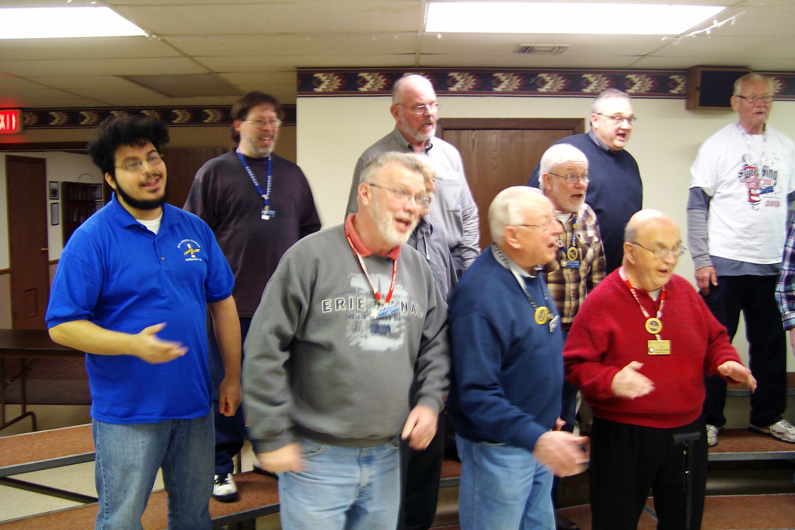

April Rehearsals
Monday April 4, 11, 18, 25
Show Dress Rehearsal April 28 at First Assembly of God Church

7:15 Warmup
7:30 Spring Show Rehearsal
8:30 Break
8:45 Tag Time
8:50 Spring Show Rehearsal
9:30 “Keep the Whole World Singing” Dismissal
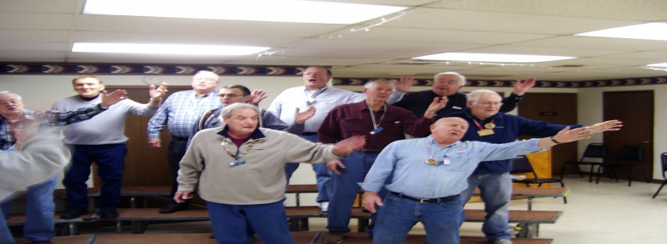
Spring Show

Ain’t A That Good News

Our spring show will be on April 30th with shows at 3pm and 7pm. Our guest quartet will be “Shoptimus Prime” They are the International Collegiate Silver Medalists for 2013. Check out their website at www.shoptimusprimequartet.com

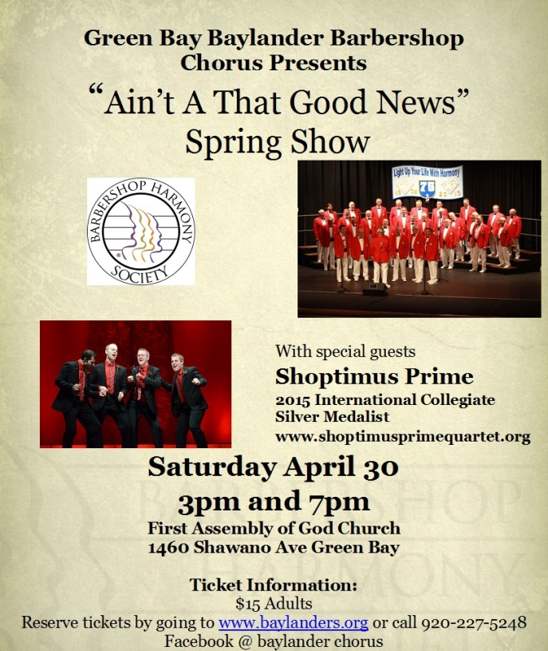
Honor Flight

The next honor flight will be returning to Appleton Airport on April 13. Some people from the chorus were planning to go to the welcome home ceremony when the plane arrives about 8pm.
Music in the Park

Our next performance after our spring show will be the Music in the Park in June. This will be our final performance for the season.

Spring Show Tickets are available. Lets get out and sell, sell, sell. This is a good opportunity to get fliers in all local churches to let them know about our Gospel Theme Show. Please remind your friends to “like” baylander chorus on facebook in order to get the message out on social media.
Rehearsal Schedule
Monday’s 7:15 to 9:30 Green Bay Elks Lodge

If you have any information you wish to add to the newsletter please send an e-mail to Jim Harsh at ronald.j.harsh@gmail.com.

Board Meeting
April 11, at 6:30pm

The deadline for the sale of program ads is coming please keep selling those ads to local businesses. Also please grab a flier and post it at a business or church. The best advertisement for our show is through word of mouth. We have an outstanding show for people to see and we would like to reach out to as many people as possible.

